Synopsis
This standard operating procedure (SOP) describes the steps needed in order to process the monthly payroll. The monthly payroll is run each month two days before the last business day of the month.

Systems Needed:
Paycor
Excel
Email
Internet

Internal Departments Impacted:
Payroll
Accounting
Employees
Human Resources (HR)

- To access Paycor open an Internet search window and enter

- Sign in to Paycor using your Username and Password.

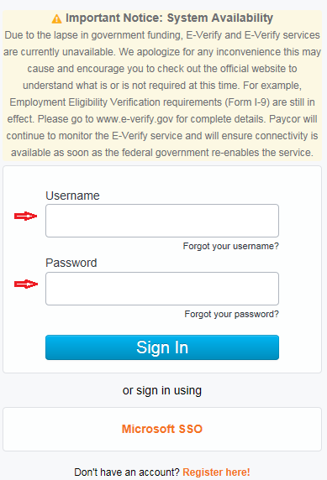

- Click “Employees” then click “Manage Time and Attendance”.

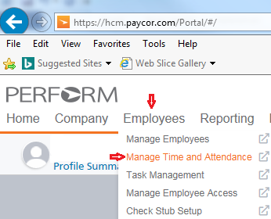

- Select the “Group” down arrow and click the pay period to be processed.

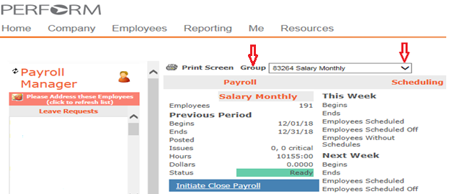

- Click “Daily Operations” and then click “Payroll Monitor”

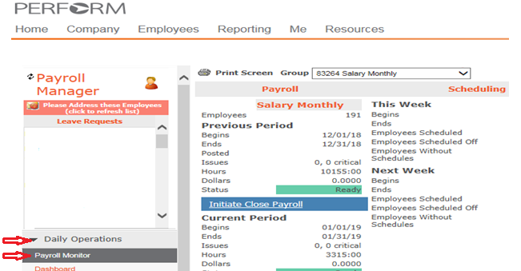

- Click the “Hours” to ensure the total hours are divisible by 7.5.
If yes proceed to step 12, if no proceed to step 7.
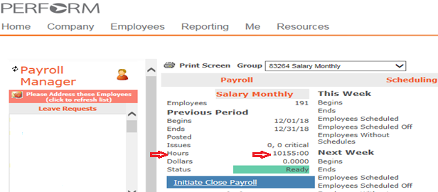

- Click Excel to transfer the information into an excel file to review.
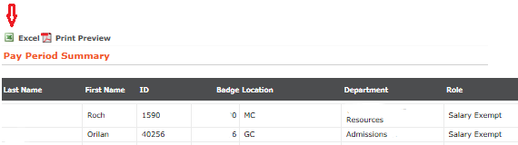

- Click “Open” to review your information.

- Review the “Non Wrkd Hrs” to verify even numbers, if there are uneven numbers click on the number to review the employees PTO time request and correct if needed.

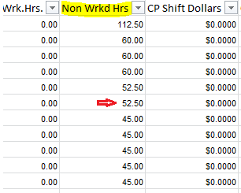

- Click the “TimeCards By Pay Period” and then click “Salary TimeCards” and click Excel.
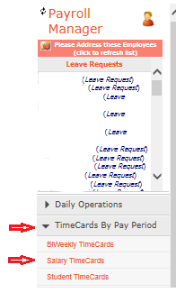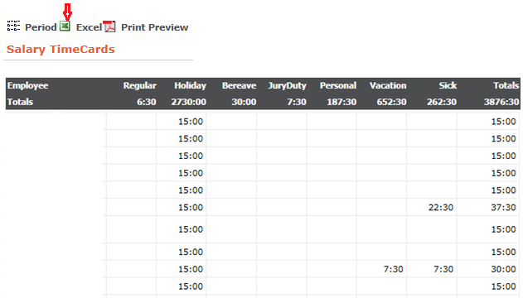

- Down load to Excel and save to your Pay Date:

- Next, import the time make sure you are still in the pay group you want to process. Double check your “Group”, then click “Initiate Close Payroll” (blue bar). This process may take up to a few minutes, once completed you will receive a message (blue bar) “Ready”.

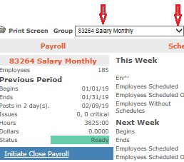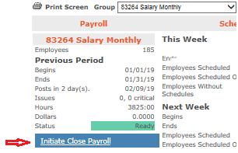

- At the top of the Paycor page click “Company” then “Pay Employees”.

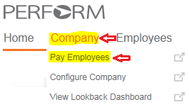

- When processing the monthly pay there will be three different pays to process one at a time “9 Month”, “Adjunct” and “Monthly”. Review the “Paygroup”,” Process Date” and “Pay Period” for your pay that you are processing and click .
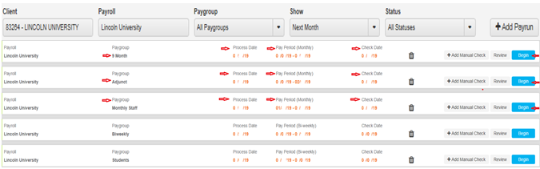

- Click the “Time Card Group” you want to process. Then click . DO NOT CLICK Submit Payrun
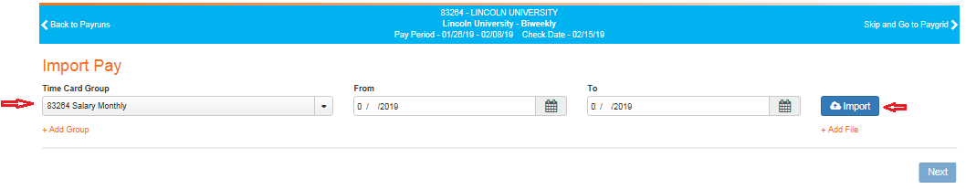

- If there are any errors they will be highlighted at the top, click the open button to view the description of the error(s) and make all correction in the pay grid to clear the errors. If the errors are not cleared contact Paycor 855-565-3285and speak with Paycor Payroll.

- Click “Ignore Errors and Finish” which will bring you back to the paygrid.

- Click “Pre-Post” open and download to your excel , select your year and your paygroup. (Save all pre-post to excel that you run and save them in order number sequence)
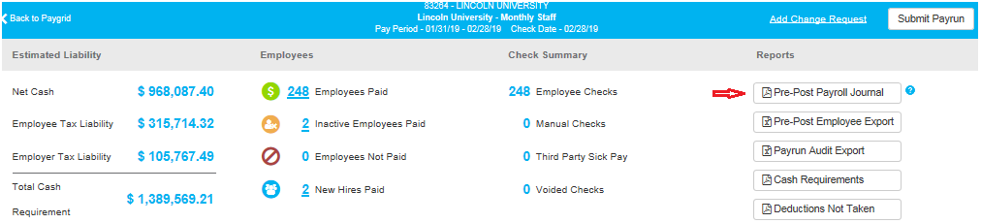

- Open the Additional Earnings spreadsheet in excel (Additional Pay Schedule): Use this spreadsheet to pay additional earnings in the Paycor grid. Add these additional earnings to Paycor Pay Grid.

Name: employee to be paid
Current: pay schedule - monthly (MN) or adjunct (4MN) or faculty (9MN)
Paycor Dept: department number used
Paycor Earned: type of pay to use
Current Month: gross amount to pay

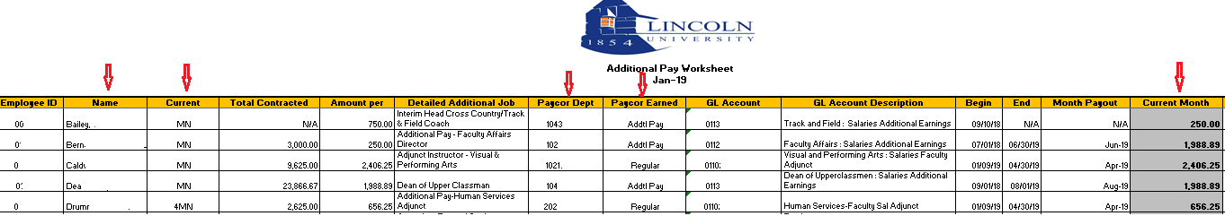

- Open the Adjustment Reports spreadsheet in excel (Monthly): Use this spreadsheet to adjust and or pay the employee. Add these adjustments to Paycor Pay Grid.

Name: employee’s name
Current Paygroup: pay schedule - monthly (MN) or adjunct (4MN) or faculty (9MN)
Adjustment Type: type of adjustment needed
Total Amount: dollar amount of the adjustment
Amount per Month: dollar amount to pay each month
Additional Total Hours: hours to be paid
Number of Pay Periods: pay periods to pay this adjustment
End Date: end of the adjustment
Notes: clarification of the adjustment
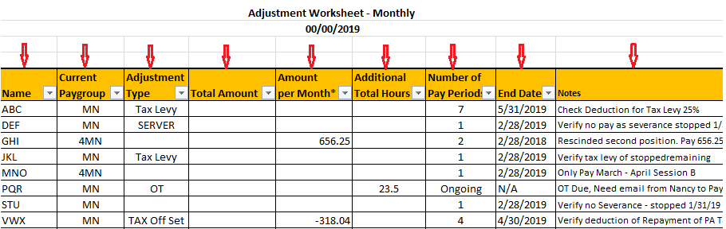

- In the Paycor Pay grid update all the information from the Additional Earning and Adjustments Reports into each employee’s grid. Find the employees name and enter the information in order to pay each employee’s.
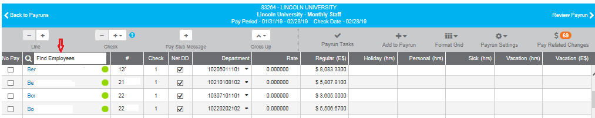

- Once all the information has been entered click “Review Payrun” .

- Click “Pre-Post Payroll Journal” to download your pay information and then save to excel (see step 18)
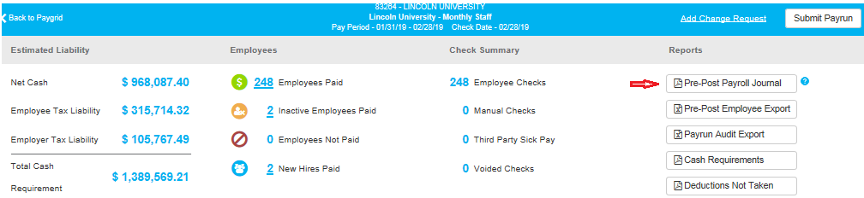

- Review the pre-post to ensure all entries are correct once all clear go back to Paycor and by 2:45pm eastern time.
