Synopsis
This standard operating procedure (SOP) describes the steps needed in order to pay and reconcile Union Dues.

Systems Needed:
Excel
Printer
Purchase Requisition Form

Internal Departments Impacted:
Payroll
Accounting
Employees
Human Resources (HR)

- Use Purchase Requisition forms located at the desk of the Payroll Specialist, one purchase requisition form for each AFSCME, PAL and LUCAAUP.
  - AFSCME: Bi-Weekly (twice a month except for 3 pay cycle months)
  - PAL: Bi-Weekly (twice a month except for 3 pay cycle months)
  - LUCAAUP: Monthly (end of each month)
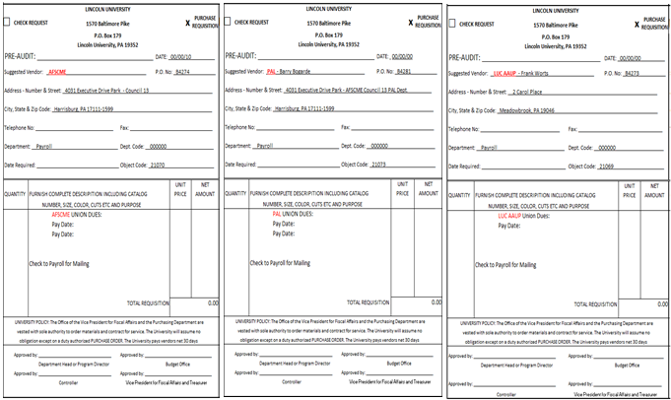

- Access Excel, Payroll, Payroll Reports, type of pay cycle you need, year, payroll report, payroll journal. If a Biweekly and Monthly pay dates are on the same day then both bi-weekly and monthly payroll reports will be in the monthly report combined.
or
or

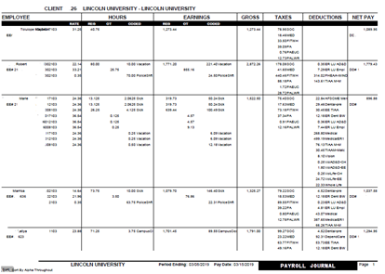

- In your report press “Ctrl F” on your key board this will bring up the “Find”.

- Enter AFSCME and hit next or enter on your keyboard.
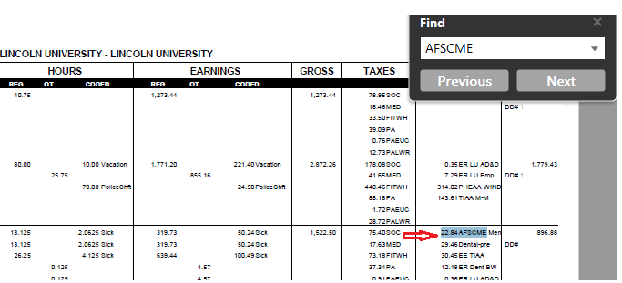

- Open an Excel spreadsheet and enter each name and dollar amount associated with AFSCME. Continue all the way through the report until the end to have your totals match the report.
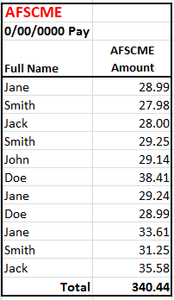

- Your end total should match your Excel spreadsheet. Do this process for all the three types of Union Dues.
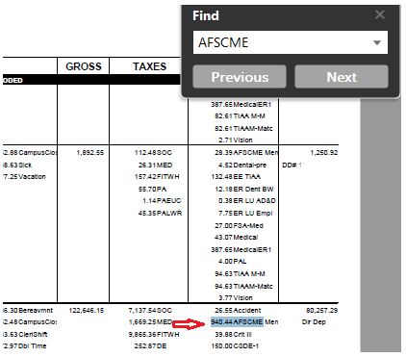

- Process the Excel spreadsheet for all three types of Union Dues
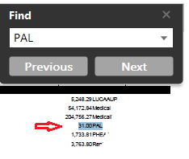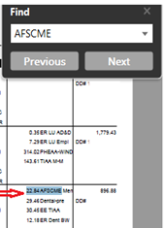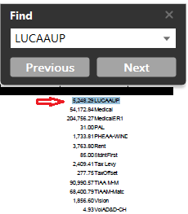

- Fill out the Purchase Requisition form for each Union due (PAL, AFSCME, LUCAAUP).
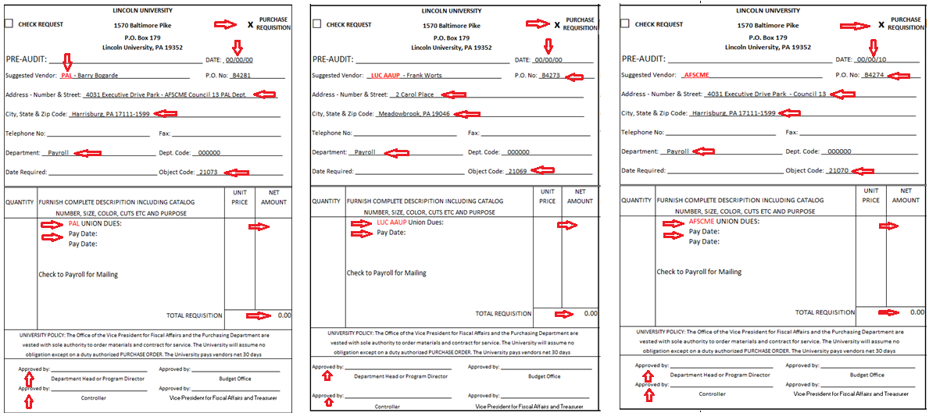

- Print out the Excel spreadsheet with all the names and dollar amounts and print out the Purchase Requisition form for each.

- Hand deliver each form to management to sign.

- Once you receive the form back hand deliver and put in the AP departments in-box.

- Make a copy of each of the Excel spreadsheets with the names and dollar amounts and attach to the live check when you receive it back and use a separate envelope along with the Excel spreadsheet and mail the live check and spreadsheet to the address written on the check.

