Life Insurance Accrual

The purpose of this journal entry is to accrue life insurance expense. This entry only needs to be made if the life insurance for the current month has not yet been paid.

- Go to Colleague and type VENI
- Search for UNUM and Select (See Below)

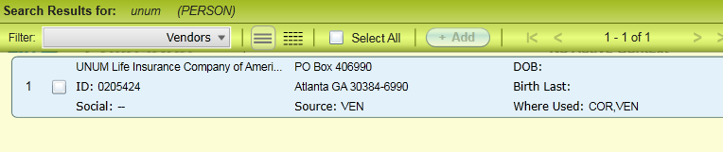
- Locate the Unum Bill paid in the month being closed and verify it is for the current month

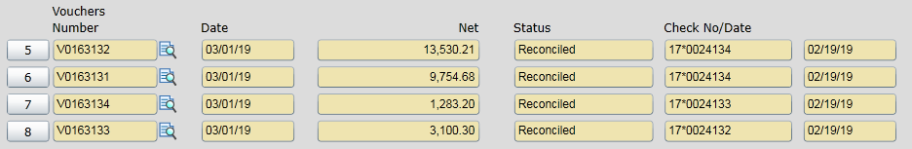

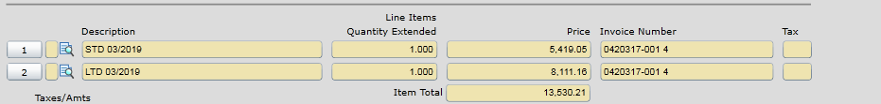

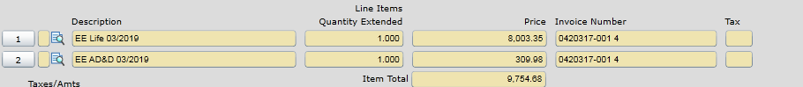
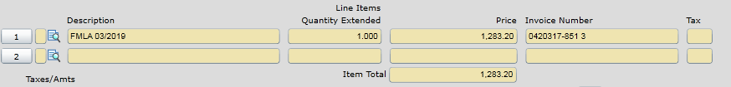
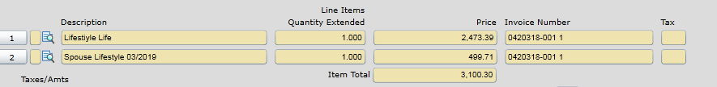

- The example above is for 3/2019. Note: All 3/19 Life invoices were paid in 3/1/19. Therefore, there is no accrual. Simply Enter “no entry needed” on the JE Checklist. (This is usually the case)
- If there are no bills paid for the month, then this will need to be accrued.
  - Use VENI and VIIN to Model the accrual off of the prior month’s amounts and coding.
    - Dr. 01-15-510001-70206 (Benefits Disability) for STD/LTD
    - Dr. 01-00-000000-21075 (UNUM – Whole Life Ins) for Spouse Lifestyle, Lifestyle Life, EE Life, EE ADD, and Ret. Life
    - Dr. 01-15-507251-74060 (VP Human Resources – Contra) for FMLA
    - Cr. 01-00-000000-21182 (Accrued Expenses) for the offset

