Procedure for Accrued Expenses Monthly JE

- Open the previous month’s Account analysis for 01-00-000000-21182
- Save the previous months account analysis in the current month’s folder
- Copy the values from the prior month to a column to the right of the account analysis schedule.
- Print out a GLTB for 01-00-000000-21182 for the month of your entry
- Relieve the values that were reversed from the prior month’s accruals (The sum of your working column should now equal the current balance in the GL.)

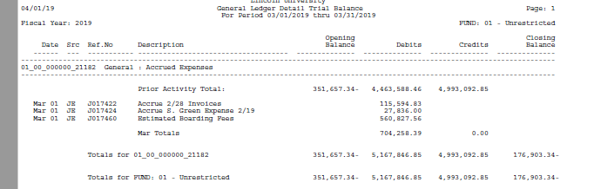
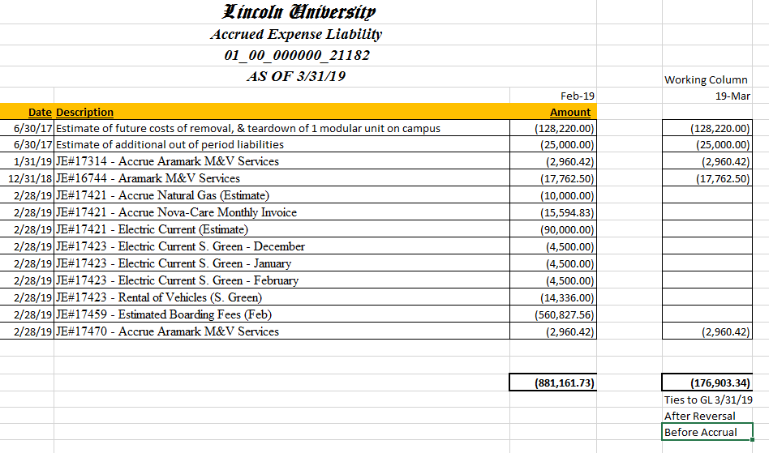
- Review prior month reversals for any re-accrual needed
- Review Utility Bills for payment using “Utilities Invoices” spreadsheet located in the AP folder of the Business Office Drive
- Re-Accrue and Accrue as needed (See updated worksheet below.)
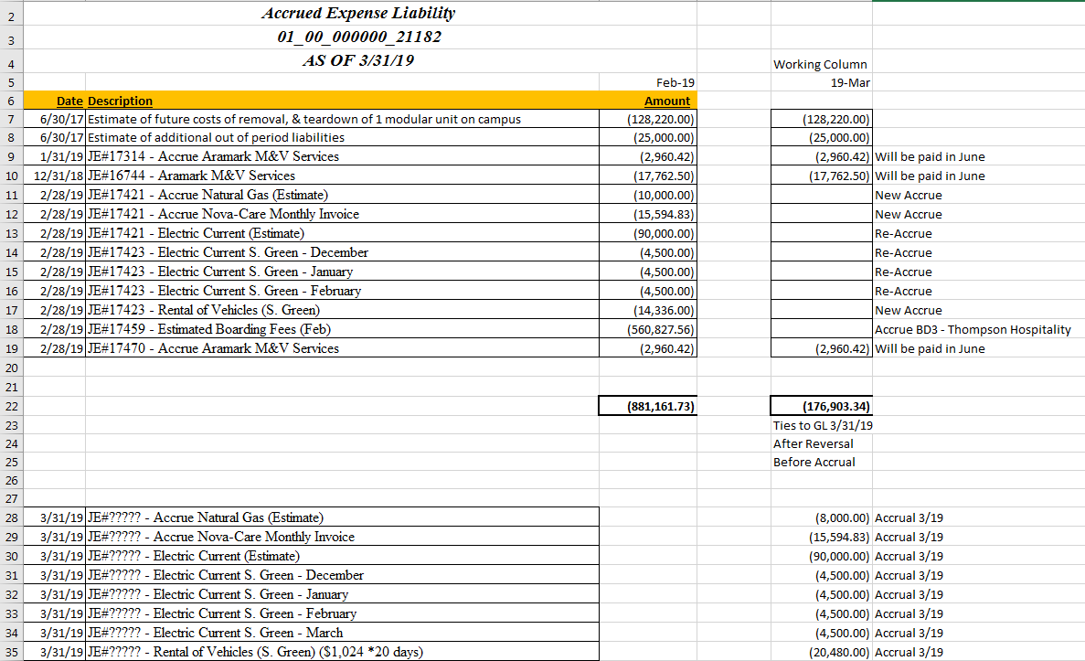

- Accrual Entry should look like below
