Paycor Labor Distribution
SYNOPSIS: The Labor Distribution report is run after every payroll cycle. Once completed, the report provides important financial information pertaining to Lincoln University’s fiscal responsibility. After it is run it is then formatted and will provide all of the labor charges associated with that particular pay. It is important to maintain the Labor Access Database to ensure that any changes pertaining to labor expenses are recorded in both the GL (general ledger) and the access database. Failure to do this will result in both of them being out of sync with each other which will require additional research and updating to either the GL or the Data Base.

STAKEHOLDERS:
Lincoln University Employees
Payroll
Business Office

EQUIPMENT NEEDED:
Microsoft Excel
MS Access for Oracle

PROCESS STEPS:
- Login into Paycor
- Select Reporting
- Select Create Reports and Analytics
- Then select my reports
5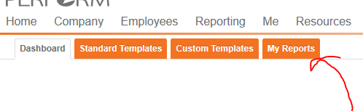
- Select “employee benefit classification”
- Then run report 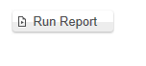
- Once the report is created click on the open button
- At the botton of the report directory select :”Save As”
- Save the report in the following folder with the following name:
\\FS2 departments\Payroll\Labor Distribution\employee benefit classification.csv
- Next run the “General Ledger – Employee Detail Report“ and save it as “labor distribution”
- Save another copy with a date specific name i.e. “Labor distribution 20190820”
- Next open access:
\\FS2\departments\Payroll\Labor Distribution\Payco_labor_distribution.accdb
- 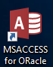
- Run Macro 001a step 1 update report parameters. Update the parameters with the correct pyroll date and pay cycle that is being run.
- Next, run Macro 1 import labor distribution and employee files
- Run Macro 2 History – This loads the GL employee history file and exports the labor distribution file.
- Macro 4 Confirm Total for Gross Pay is next. Please make sure that you comapre the totals to the payroll register to ensure the data is being pulled correctly.
- Open up the exported report entitled “Labor distribution” and total the “Gross” column to ensure that all records exported correctly.
- Then, rename the file to a date specific name. Save the file in the following folder and distribute the report accodingly : \\FS2\departments\Payroll\Labor Distribution\Completed
- At the end of the month, the data for the entire reporting month and the YTD is compiled, formatted and distributed.
- To complete this report follow the additional steps listed below. Filter on the entire YTD that is to be reported.
- Then filter under students in the benefit classification tab to remove all of the student labor.
- Filter again under “adjuncts” and place them in another tab as they are separate reporting item.
- Sort the report by department, last name and date
- In excel under Data>Sort select subtotal. 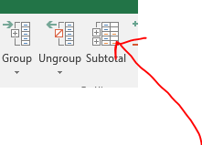
- The variables are : 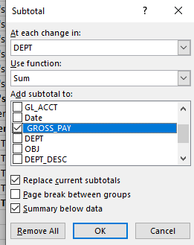
- Format the report by ensurinag all numbers are formatted and then bolding the department name and the total dollar amount for each department.
- This tab should be labeled ‘YTD”
- Filter on the current month, control g, visible cells only, copy in order to copy those visible rows.
- Paste that data in another tab and label it the current month that is being reported.
- Complete steps 26-30 to repeat the process for the Adjunct Paygrpup.
- Make sure all of the tabs in the final report are formatted correctly and include a header and a footer.
- Once all steps are completed and the report is saved in the “to Chuck >YY” folder print copies and distribute them to the Fiscal Officcer, Budget Officer and the Controller for their review of the data.
- Any changes that they identify will then have to be corrected in the GL and in Access Database simultaneously to ensure they are both in sync,

