LABOR REPORTS VERIFICATION:

- On the first business day of each week, locate and open the {See Figure A} Special Programs “P” drive. Within the “P” drive, scroll down to the bottom of the list and open the Excel file “Special_Programs_Labor_Dist_Report.” (The file updates over the weekend.)

Figure A:

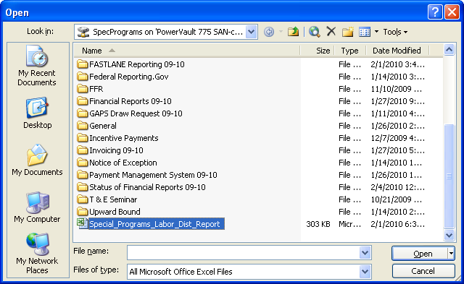

- Left click on the {See Figure B} “Pay Period Check Date” column. On the tool bar across the top, Click “Data.” Then select “Filter”; then select “Auto Filter.”

Figure B:

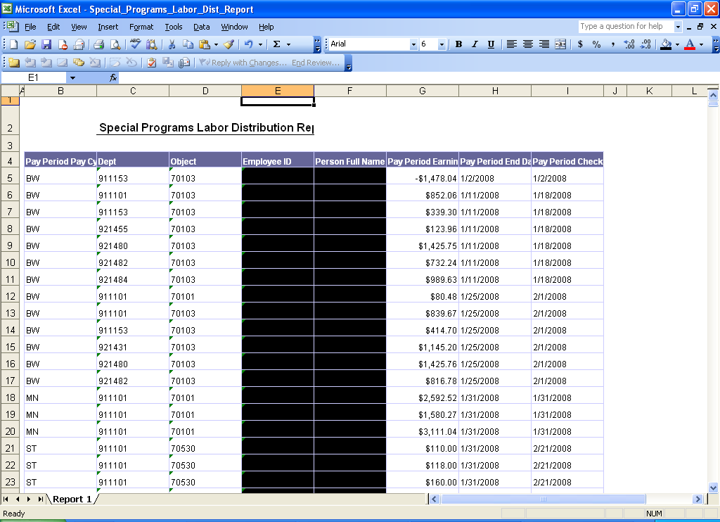

- Drop down arrows will appear to the right of each column heading. {See Figure C}

Figure C:

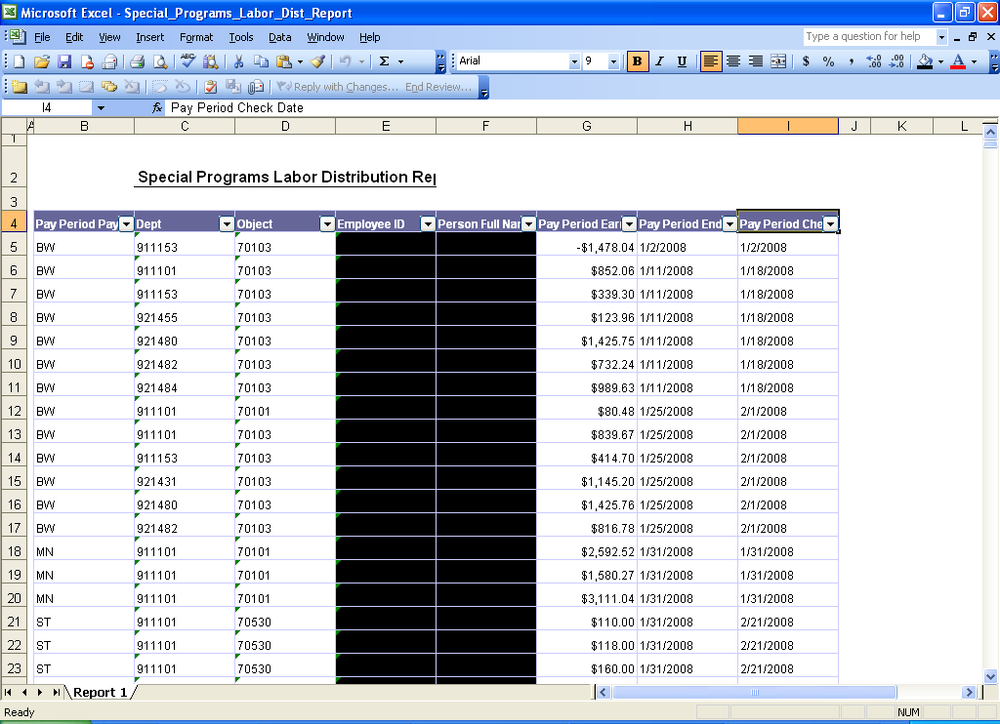

- Click on the drop down arrow {See Figure C} on the “Pay Period Check Date” column. A box will drop down. {See Figure D}

Figure D:

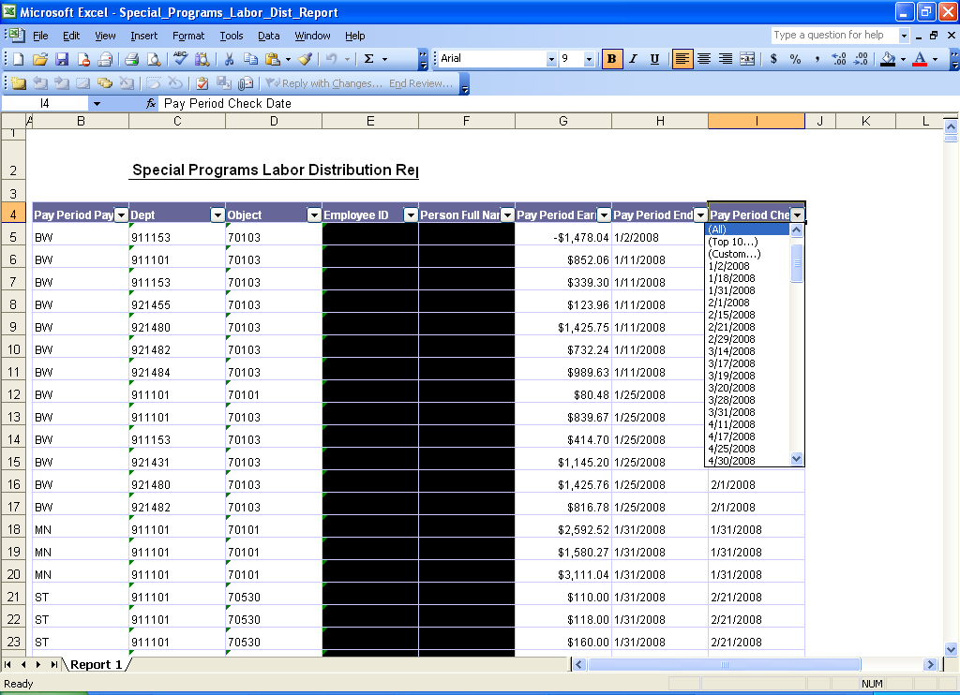

- Scroll down and select the pay period you want to see, example {See Figure E} 1/29/2010.

Figure E:

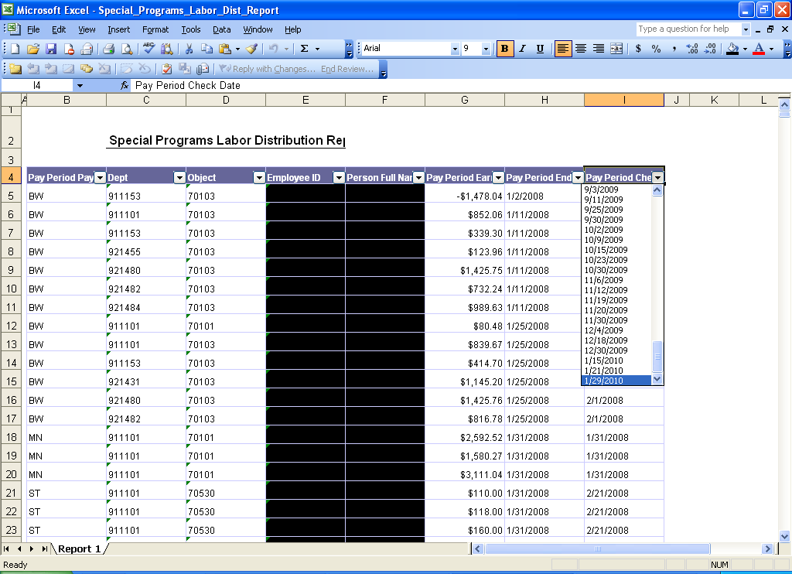

- If more than one Pay Cycle ID {See Figure F} is included in that check date, sort by clicking on the Pay Cycle ID column (first column).

Figure F:

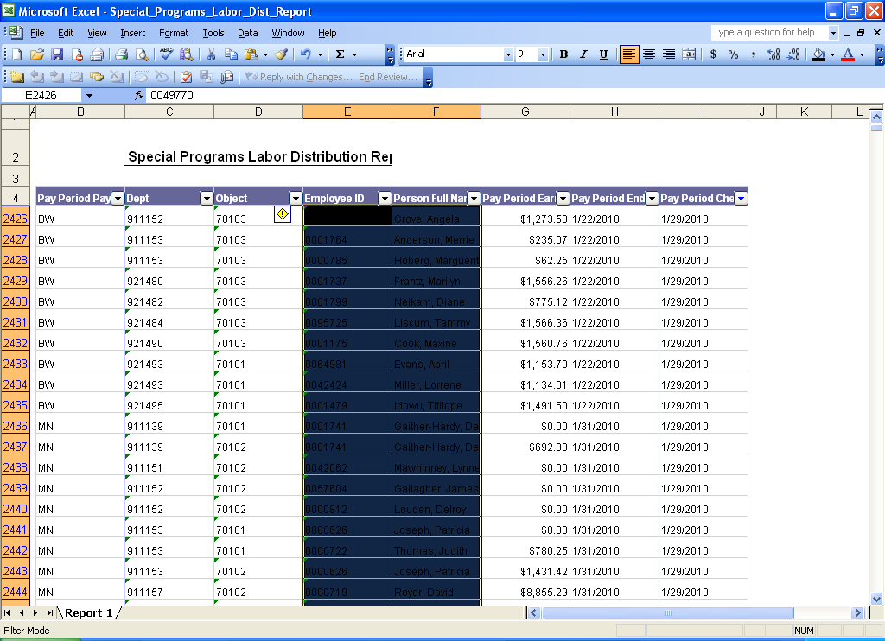

- Choose MN or BW or ST and only those checks will be visible {See Figure G}.

Figure G:

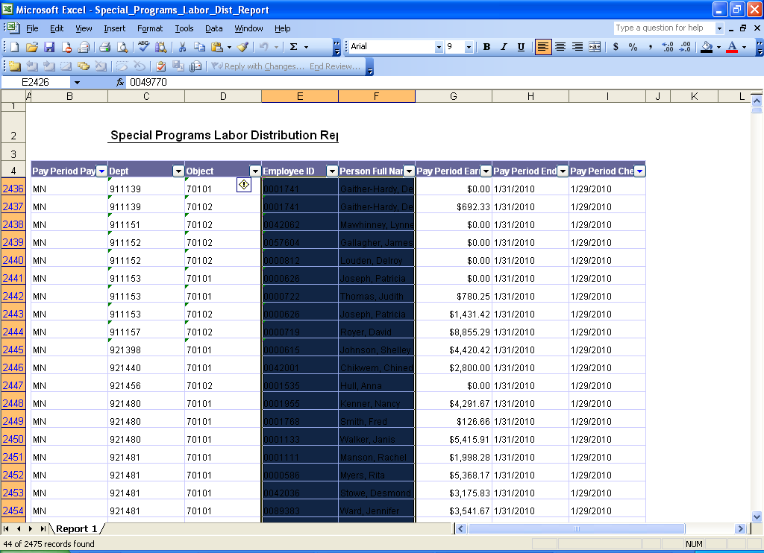

- Save the file with the pay check date and pay cycle ID as part of the name {See Figure H}. Go through the process again and save a file for each pay cycle ID. Now you can begin verifying labor charges to Special Programs departments.

Figure H:

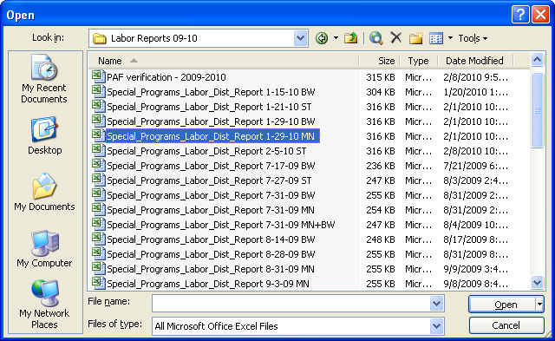

- Establish an Excel workbook file called, for example, “PAF verification 2009-2010.” {See Figure I}.

Figure I:

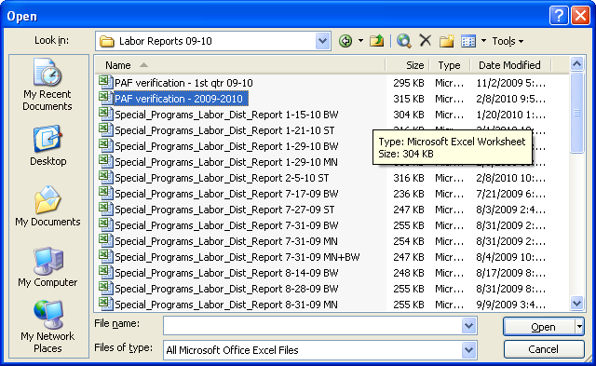

- All salaries charged to Special Programs departments should be approved by the Sr. Grants Accountant. Approvals are based upon budget availability for the particular position within the approved grant budget. As the PAFs (Personnel Action Forms) are approved by Special Programs, the name of the person, PAF dates and amounts, etc., are entered into the PAF verification workbook {See Figure J}. A separate worksheet is established for each grant department. Add columns for salaries paid each month. Use the Special Programs Labor Distribution Reports discussed above to populate the actual salaries paid to each person each month. Enter notations beside any PAFs with special treatment.

Figure J:

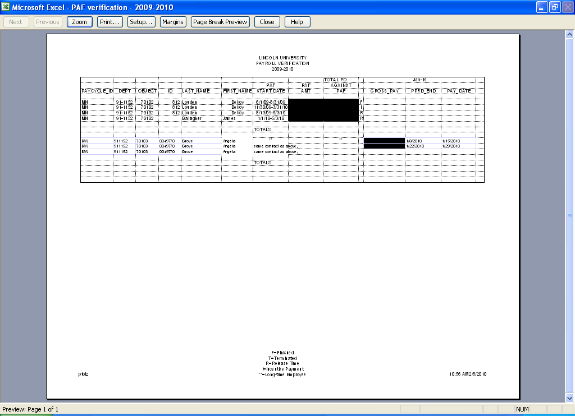

- Differences between the Labor Distribution Report, the PAF Verification worksheets, and the general ledger must be investigated in a timely manner. For example, the Labor Distribution Report may show a salary charged to a grant for which Special Programs has no PAF. Or the Labor Distribution Report may show that a PAF was not charged to a grant that should have been. Contact payroll and human resources to resolve the differences. Compare charges to the general ledger {See Figure K} to the Payroll Verification file for each grant on a monthly basis. Journal entries may be needed to correct the general ledger and the PAF Verification file updated to reflect the correct information.

Figure K:

