How to change system close mapping for fund balance (GLMT)

The system follows closing rules when a new account is established.
- A new fund 1 income statement account will automatically close to 01_00_719999_33001 - Accumulated <Excess>Deficit : Unrestricted Fund Balance
- All other accounts (Fund 2 and above) will create and close to 02-XX-XXXXXX-33002. (Program and department code will be the same as the new account, fund will default to 33002.)
For new Fund 3 Accounts (Permanently Restricted) this causes a problem. For example, a new restricted contribution to fund three (Example – A new endowed fund is created with a credit to 03-00-771078-46501. Without intervention to the system close mapping, this fund will close to 03-00-771078-33002. The correct coding should be to 03_00_771078_33003.)

Below are steps to direct the fund closing mapping to the correct account.

- Enter GLMT
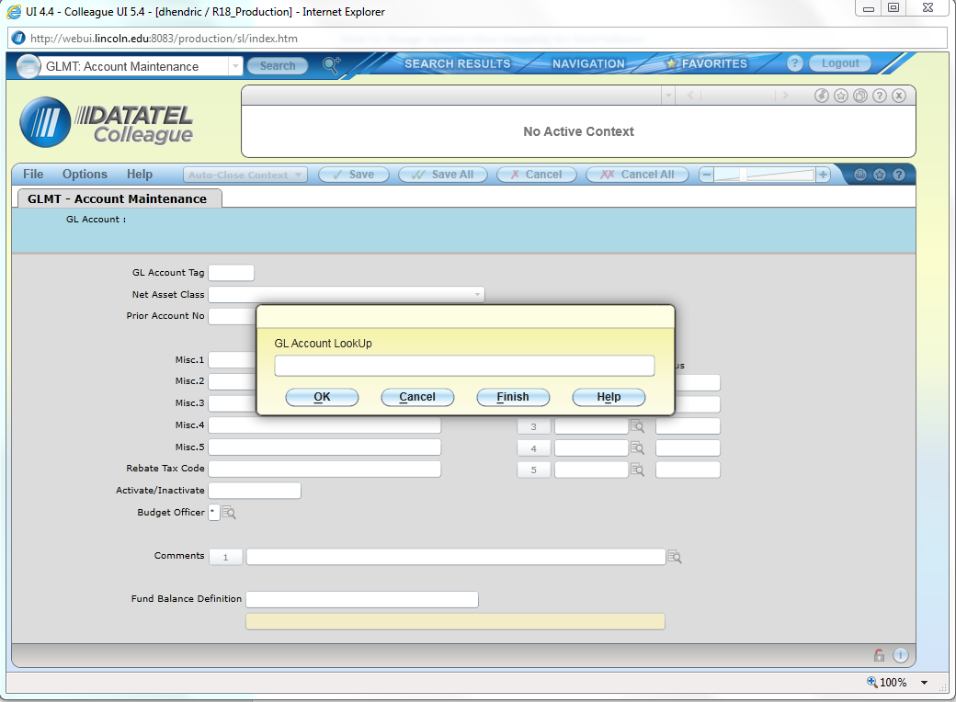

- Enter Income Statement Account to be remapped
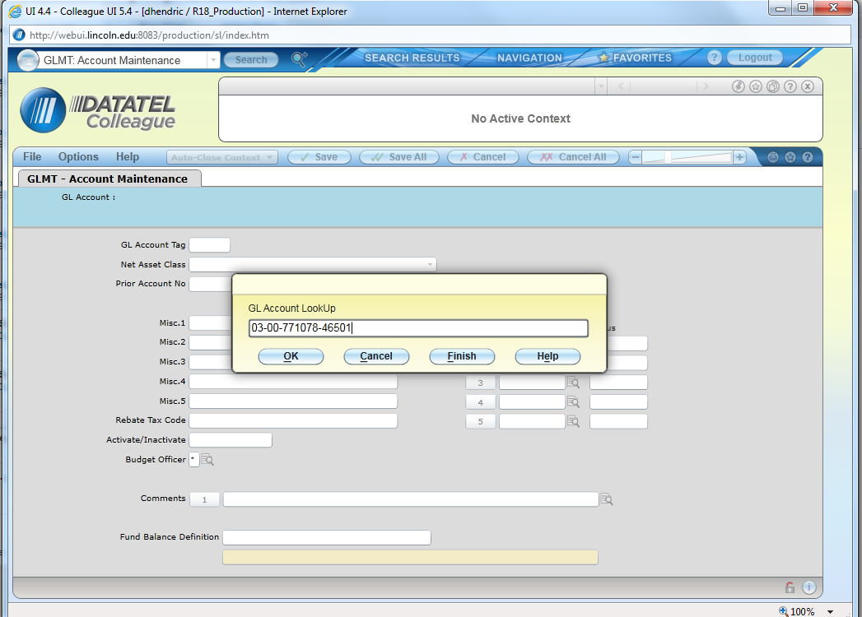
- Note the default mapping is pointing to “33002”(Temp Restricted) (See Below)
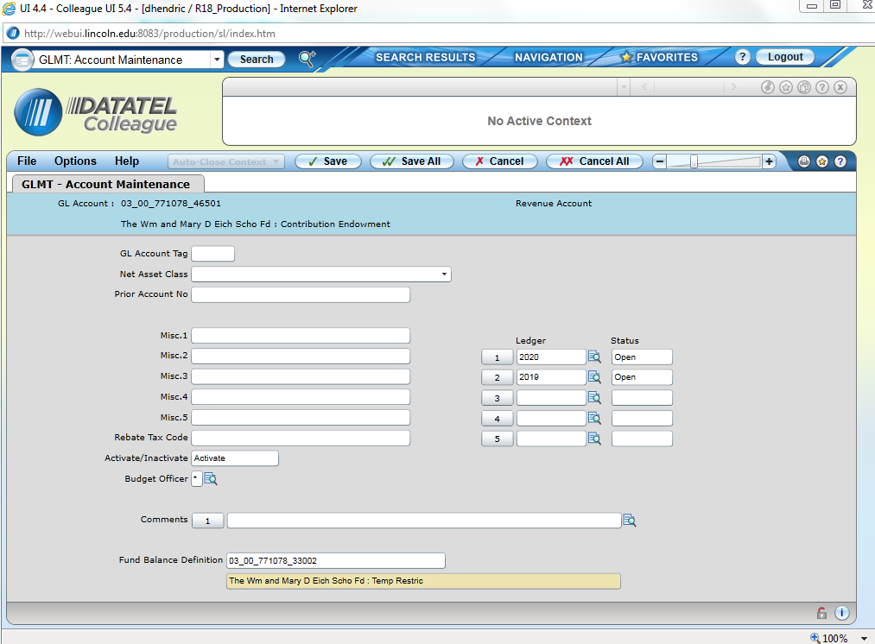
- Edit the “Fund Balance Definition” to show “33003.”
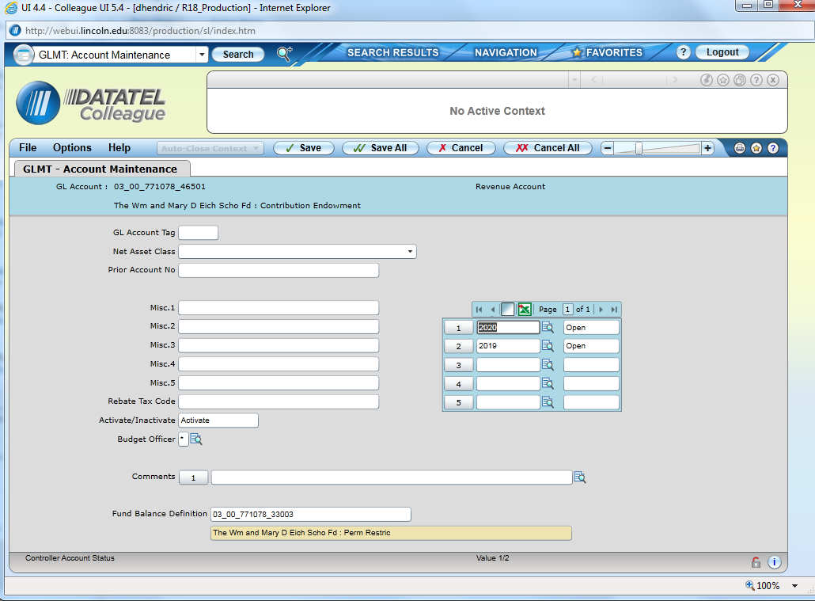
- Select “Save All” (You will get a message asking for a budget officer to be assigned – Select “OK” ignoring this message.)

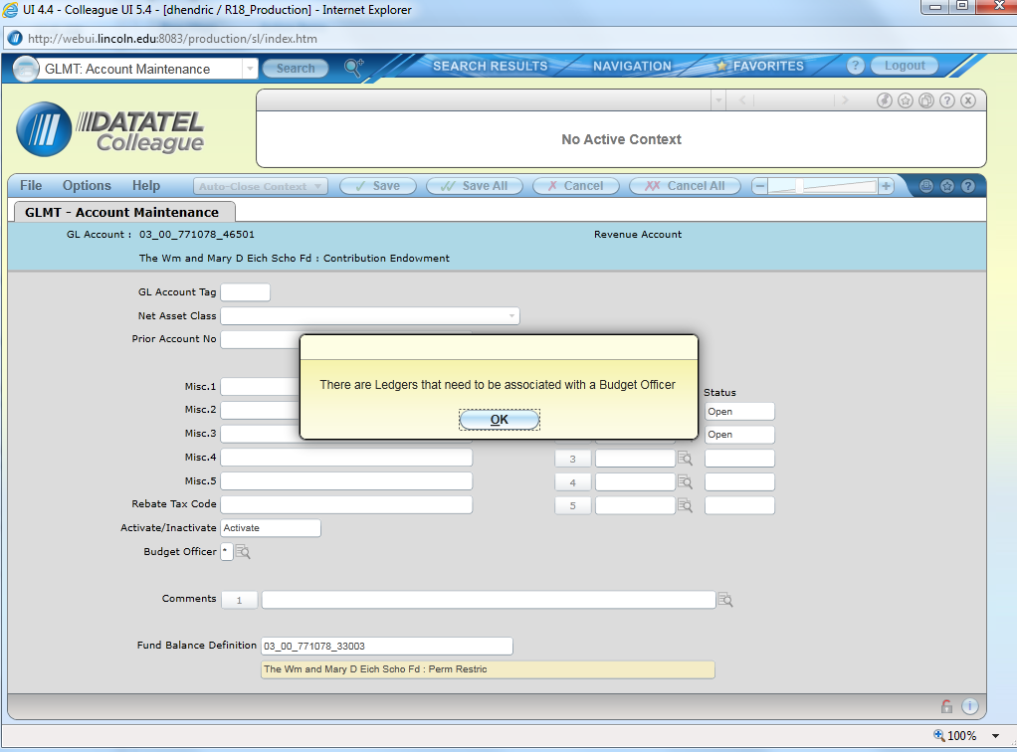
- The system will now close to the correct fund balance account
