How to Open/Freeze/Close Accounts for years (MACS)

- Type MACS and enter three dots “…” to show available open years
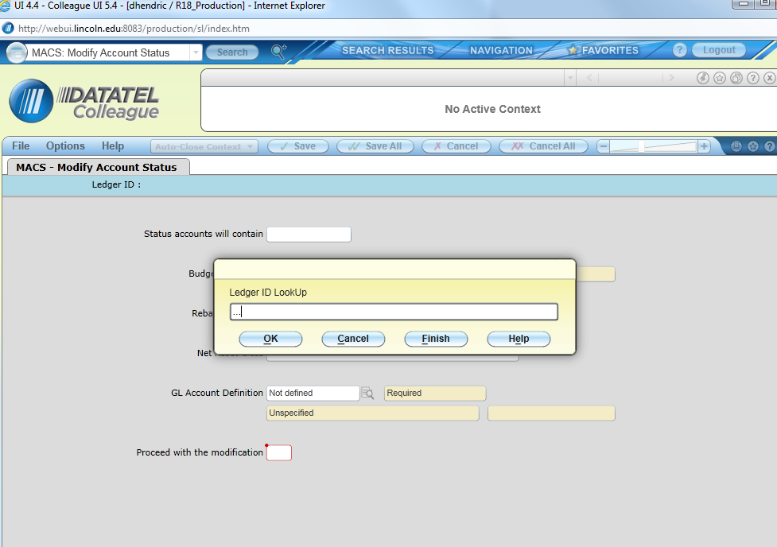

In the example below, there are two open years.
Note: For this process to work, the account to be modified must have a status of “active.” This can be checked by using “GLMT.” Note also that you could both activate and open an account using GLMT without having to use MACS.
- Select Desired Fiscal Year
- For the purpose of this example we will open an account. (“O”)

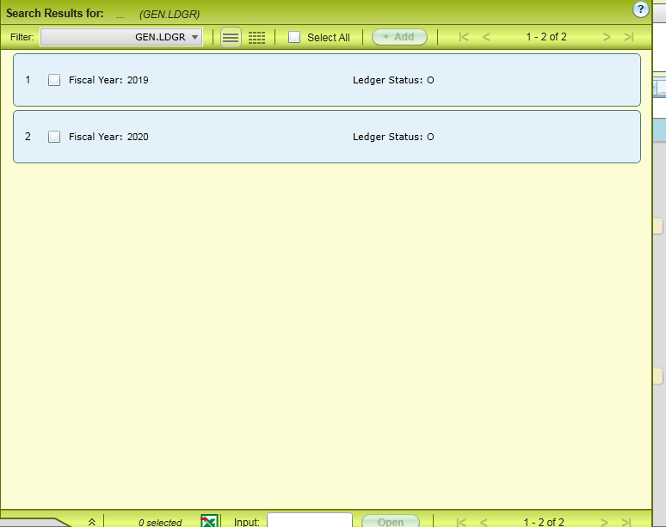

- First enter in the field “Status Accounts will Contain” “O” for Open…”F” for Frozen or “A” for Authorized (We’re using “O” for this example…..process is the same for all choices.) See screenshot below.
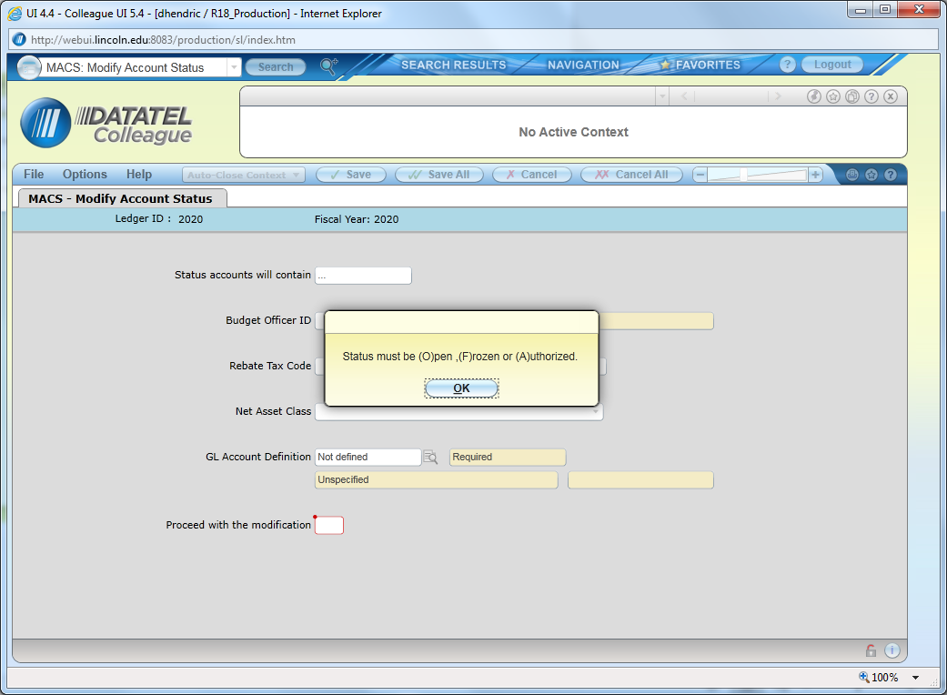

- Detail in to “GL Account Definition” by selecting the magnifying glass (see below)…Then enter the account number to be opened.
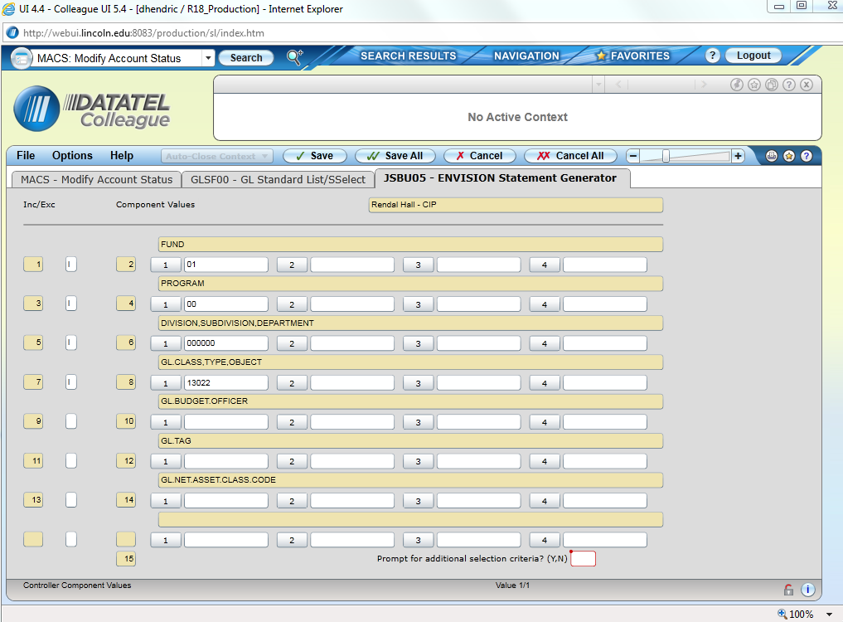

- When finished entering the account number, select “Save All.”

Note: that in this example we’re deleting one test account and have defined Fund, Program, Department, and Object. If we want to delete all accounts in a department, simply enter the department number and leave the other fields blank.
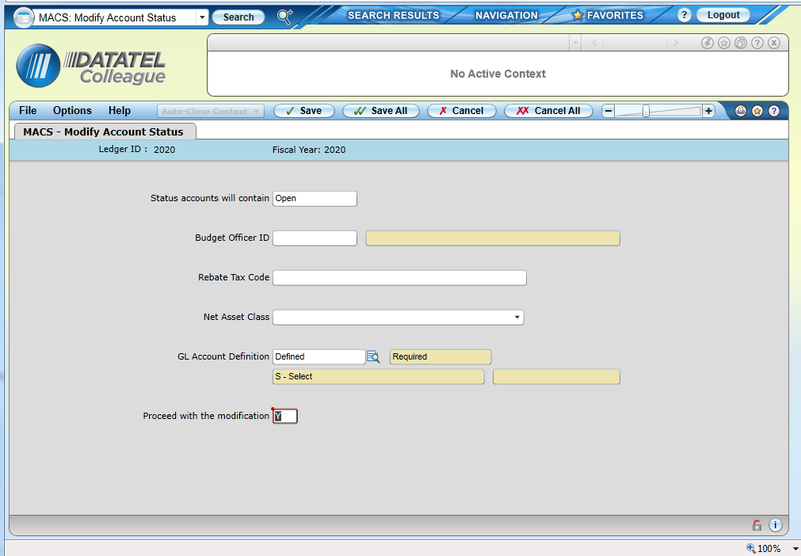

- Select “Y” to proceed with the modification and Select “Save All” (No confirmation screen will show up. You can check that you were successful by checking AHST for the account and verifying the open year appears.)
The selected account is now open for fiscal year 2020.

