Lincoln University
Notice of Employee
Termination / Resignation

Employee Name:
Title:
Department:

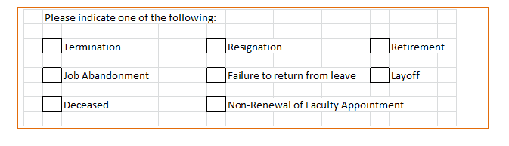
*It is recommended that employees provide Lincoln University with a two week written notice in order to be eligible to be rehired.

Please check the applicable box: Written (Copy is Attached) Verbal

Effective Date of Resignation / Termination:

Vacation Leave Payout (to be paid on the subsequent month after the employee is terminated)

**To calculate the amount of hours to be paid refer to the leave calculation template.

Total hours to be paid:

Approved By: Date:

