Delta Dental Benefit Reconciliation
SYNOPSIS: Delta Dental is the dental provider at Lincoln University. Every month, Lincoln is invoiced by the provider for the benefit cost for the subsequent month. The Payroll Benefit representative at Lincoln will then provide the information, including all charging instructions, to AP who will issue the payment to the provider. In addition the Payroll Benefit representative will reconcile the invoice detail to the Payroll employee and employer deductions to ensure the validity of invoice charges. Reconciling items may be due to the fact that the invoicing is done in advance, not in real time. Invoices include a Member Activity page of retroactive charges or credits. In addition there will always be outstanding payroll transactions not reflected on the invoice. Each year a schedule is built for the 9 month employees in order to assist in reconciling the prepayment of their health premiums. This procedure provides step by step instructions on how to complete this process.

STAKEHOLDERS:
Lincoln University Employees who participate in the plan
Payroll / Benefit Department
Lincoln University HR
Delta Dental

EQUIPMENT NEEDED:
Microsoft Excel
MS Access for Oracle
Adobe Reader

PROCESS STEPS:
- Log into the Delta Dental Website by clicking on the following url: https://www.deltadentalins.com
- Once you have accessed the website click on login in order to sign in. See below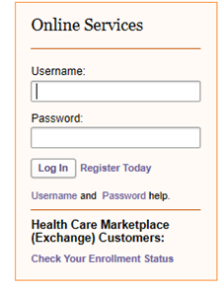

- Enter in your user name and password and click “Login”
- On the top menu bar please select “Enrollment and Billing”
- This will bring you to the employer portal. Next click on “Invoice and Payment”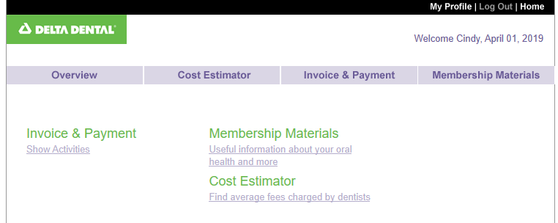
- If you are reconciling the most recent invoice simply click on the invoice number. 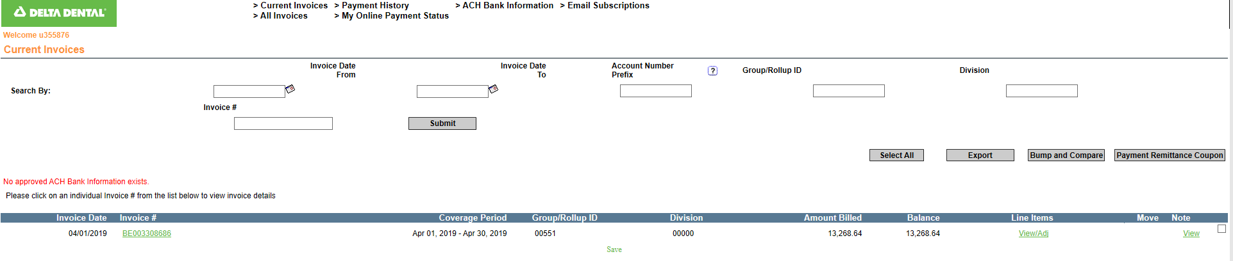
- Click on Download found to the right of the page. 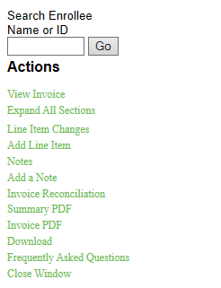
- Save the file in the Delta Dental Folder for the month that is being reconciled. Once saved all of the EE detail will populate.
- Open the file that has downloaded and click on “Enable Editing”
- Save the invoice as \\fs2\departments\HR_payroll\ibx_invoice_YYYYMM
- Next log into Paycor
- Select Reporting/Reports and Analytics/My reports/ Paid Benefits. If this is the first time you are running this report you must select Custom Template. Once you run the report it will then become part of “My Reports”
- Open the report by clicking on
- Select Filters and change the “To” date to the last pay date of the month being reconciled
- Select Run Report
- Select Action save As \\fs2\department\HR_payroll\Delta Dental\paid benefits.xlsx
- Next again under “Reporting” select saved and shared reports and then “Benefit Reconciliation Data” Select export and save as: \\fs2\departments\HR_payroll\Ibx reconciliation\benefit reconciliation data.xlsx
- Refer back to the invoice file for the month to be reconciled and save it as: \\fs2\departments\HR_payroll\Delta reconciliation\Delta__invoice.xls
- Open Delta_invoice.xlsx and delete the rows down to the 1st Enrollee Header record and rename sheet to invoice.
- Open delta reconciliation. Accdb using 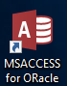
- Select Reconciliation setup - Enter the Coverage Period End date from the invoice 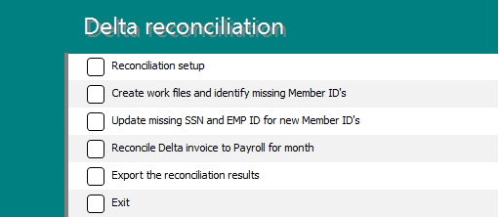
- Select Create work files and identify missing Member ID’s
- Select Update missing SSN and EMP ID for new Member ID’s. This will confirm both the payroll and invoice totals to ensure all records imported correctly.
- Enter the unmasked SSN’s and Employee Id’s to the table.
- Select Reconcile Delta invoice to Payroll for month – You may get a report showing duplicates. These are probably due to SSN changes. Make sure to remove any duplicate records from the file.
- Select “Export the reconciliation results” – Creates\\fs2\departments\HR_payroll\Delta reconciliation\Delta_reconciliation.xlsx
- Select Exit
- Rename Delta_reconciliation.xlsx to Month specific
- Rename Enrollee adjustments.xlsx to Month specific
- Apply the Enrollee adjustments to prior month reconciliations.

