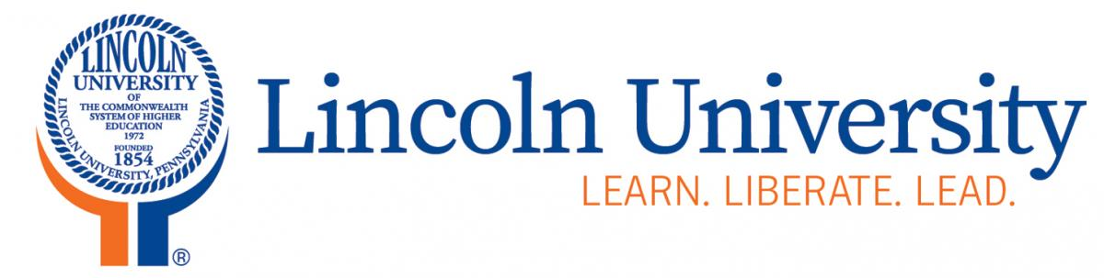
Office of Sponsored Programs

1570 Baltimore Pike
Lincoln University, PA 19352

484-365-7234 phone
484-365-7691 fax
osp@lincoln.edu

LINCOLN UNIVERSITY
MEMORANDUM OF UNDERSTANDING

This External Memorandum of Understanding (EMOU) shall put forth the general scope of cooperation by which Lincoln University intends to seek opportunities for collaboration to (general project activity).

Lincoln University and the following organizations will partner to provide (services in furtherance of program goals).

- Organization:
(Here describe organization, their scope of work in relation to the project, organization representatives involved with coordinating between Lincoln and organization and any fund that will be allocated to organization for the project)

- Organization:
(Here describe organization, their scope of work in relation to the project, organization representatives involved with coordinating between Lincoln and organization and any fund that will be allocated to organization for the project)

General Terms
- The terms of cooperation and partnership for each specific activity implemented under the Memorandum of Understanding shall be mutually discussed and agreed upon in writing by both parties prior to the initiation of that activity.
- The term of this MOU shall be from the date of execution until any party terminates the MOU.

The designated liaison officers for this Memorandum of Understanding are:

For: Oganization 1
Name: Name of representative
Title: Title of representative

By signing below, I commit my services and those of the (organization) to participating in the stated aspects of the Lincoln University of Pennsylvania (project title), to achieve the project goals (list project goals)

_____________________________________________ Date: __________________________
Signature

For: Organization 2
Name: Name of representative
Title: Title of representative

By signing below, I commit my services and those of the (organization) to participating in the stated aspects of the Lincoln University of Pennsylvania (project title), to achieve the project goals (list project goals)

_____________________________________________ Date: __________________________
Signature

For: Lincoln University of Pennsylvania
Name: Authorized Representative
Title: Title

By signing below, I commit my services and those of the (organization) to participating in the stated aspects of the Lincoln University of Pennsylvania (project title), to achieve the project goals (list project goals)

_____________________________________________ Date: __________________________
Signature

