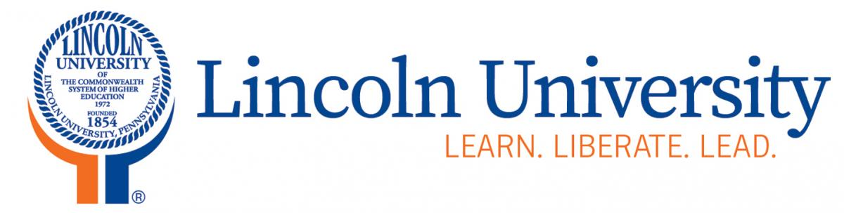
Office of Sponsored Programs

1570 Baltimore Pike
Lincoln University, PA 19352

484-365-7234 phone
484-365-7691 fax
osp@lincoln.edu

Student Confidentiality and Non-Disclosure Agreement
In consideration of being given access to information that will be valuable for my research or study in the area of: [describe] by Lincoln University ("Disclosing Party"), I agree as follows:
1. Intellectual Property and Trade Secrets
I understand that during the course of my study and/or research there may be disclosed to me or I may gain access to intellectual property, trade secrets and other proprietary or confidential information of Disclosing Party (Lincoln University). This includes, but is not limited to:
(a) technical information concerning Lincoln University's research projects, technical memoranda and correspondence, formulas, designs, devices, diagrams, software code, test results, processes, inventions; and
(b) Lincoln University’s business information, including cost information, accounting and unpublished financial information, business plans, customer lists and customer information, purchasing techniques, supplier lists and supplier information and marketing, production or merchandising systems or plans.
2. Nondisclosure of Intellectual Property and Trade Secrets
I will keep Lincoln University's intellectual property, trade secrets, and other proprietary or confidential information whether or not prepared or developed by me, in the strictest confidence. I will not disclose such secrets to anyone outside Lincoln University, (the Disclosing Party) without Lincoln University’s prior written consent. Nor will I make use of any Lincoln University intellectual property, trade secrets and other proprietary or confidential information for my own purposes or the benefit of anyone other than Lincoln University without Lincoln University's prior written consent. I will not keep Lincoln University’s intellectual property, trade secrets, and other proprietary or confidential information on my personal computer, tablet, or any other mobile device. All such materials shall be kept and/or stored on University owned property, mainframes, computers, tablets, smartphones and other such devices.
However, I have no obligation to treat as confidential any information which:
(a) was in my possession or known to me, without an obligation to keep it confidential, before such information was disclosed to me by Lincoln University;
(b) is or becomes public knowledge through a source other than me and through no fault of Employee; or
(c) is or becomes lawfully available to me from a source other than Lincoln University (the Disclosing Party).
3. Return of Materials
When my research or study with Lincoln University ends, for whatever reason, I will promptly deliver to Lincoln University all originals and copies of all documents, records, software programs, media and other materials containing any of Lincoln University’s intellectual property, trade secrets and other proprietary or confidential information. I will also return to Lincoln University all equipment, files, software programs and other intellectual and personal property belonging to Lincoln University, the Disclosing Party.
4. Review of Papers or Publications
For a period of_____years, I will submit to [Name of PI/CoPI/Supervisor] a full and complete draft of any papers, reports or proposed publications that include any information derived from my research or study with Lincoln University for its review. I shall disguise or excise from this material any data that Lincoln University deems too sensitive for disclosure.
5. Duration of Confidentiality Obligation
My obligation to maintain the confidentiality and security of Lincoln University's intellectual property, trade secrets and other proprietary or confidential information continues for so long as such material remains a trade secret and/or intellectual property.
6. General Provisions
(a) Relationships: Nothing contained in this Agreement shall be deemed to make me a partner, joint venturer or employee of Lincoln University for any purpose.
(b) Severability: If a court finds any provision of this Agreement invalid or unenforceable, the remainder of this Agreement shall be interpreted so as best to effect the intent of Lincoln University and myself.
(c) Integration: This Agreement expresses the complete understanding of the parties with respect to the subject matter and supersedes all prior proposals, agreements, representations and understandings. This Agreement may not be amended except in a writing signed by both Lincoln University and myself.
(d) Waiver: The failure to exercise any right provided in this Agreement shall not be a waiver of prior or subsequent rights.
(e) Injunctive Relief: I acknowledge that any misappropriation of any of the Confidential Information in violation of this Agreement may cause Lincoln University irreparable harm, the amount of which may be difficult to ascertain, and therefore agree that as the Disclosing Party, Lincoln University shall have the right to apply to a court of competent jurisdiction for an order enjoining any such further misappropriation and for such other relief as Lincoln University deems appropriate. This right is to be in addition to the remedies otherwise available to Lincoln University.
(f) Indemnity: I agree to indemnify Lincoln University against any and all losses, damages, claims or expenses incurred or suffered by Lincoln University as a result of my breach of this Agreement.
(g) Attorney Fees and Expenses: In a dispute arising out of or related to this Agreement, the prevailing party shall have the right to collect from the other party its reasonable attorney fees and costs and necessary expenditures.
(h) Governing Law. This Agreement shall be governed in accordance with the laws of the Commonwealth of Pennsylvania.
(i) Jurisdiction. I consent to the exclusive jurisdiction and venue of the federal and state courts located in Chester County, Pennsylvania in any action arising out of or relating to this Agreement. I waive any other venue to which I might be entitled by domicile or otherwise.
(j) Successors & Assigns. This Agreement shall bind each party's heirs, successors and assigns. Lincoln University may assign this Agreement to any party at any time. I shall not assign any of its rights or obligations under this Agreement without Lincoln University's prior written consent. Any assignment or transfer in violation of this section shall be void.
7. Signature
I have carefully read and considered all clauses of this Agreement and agree that all of the restrictions set forth are fair and reasonably required to protect Lincoln University’s interests. I have received a copy of this Agreement as signed by me and the PI/CoPI/Supervisor responsible for my engagement in the project.
Student: PI/CoPI/Supervisor:

_____________________________ _____________________________
(Signature) (Signature)

Date: ____________________ Date: _____________________

