Canvas Tip Sheet: Quizzes: QTI Format & Converter

After you create the quiz, you can set extra attempts and time on quizzes. If you have set a time limit on your quiz, you can set extra time for certain students. Your quiz must be published to add student extensions.

Steps | Directions | Image
1. Create a text file of your quiz questions | One return/enter between question and answer. Two return/enter between questions. | Question samples:  1. What is the term for the process of a leader communicating ideas, gaining acceptance of them, and motivating followers to support and implement the ideas through change?  a. Leadership  *b. Influencing  c. Management  d. Guidance  2. The first step to leadership development is self-awareness of leadership competencies.  *a) True  b) False
2. Convert text file | Canvas Quiz Converter: San Diego State University tool | http://ec2-34-207-154-191.compute-1.amazonaws.com/
3. Create Quiz Question Group |  | - In the course navigation, click Quizzes  - In the right corner, click the more options button (snowman)
- Click Manage Question Banks
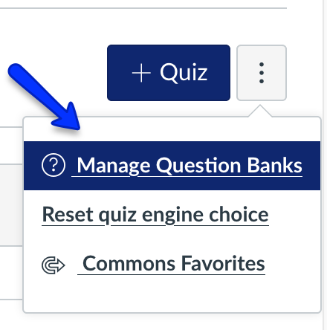
3. Import QTI zip file | Go to course settings | - Go to the Canvas course in which you want to add the quiz.  - Go to Settings, in the right sidebar (menu), click "Import Course Content"  - Select “QTI .zip file” at the bottom of the dropdown menu choices  - Locate and choose the zipped file that was generated by the converter tool  - Click "Import.”

