Question Banks
Canvas Tip Sheet: Question Banks

The question bank is used as a folder to store your questions. You may organize your question banks by topic or chapter.

If you plan to use your own quiz questions, please use the QTI format and creator to upload questions.

Steps | Directions | Image
1.Course Navigation Menu | In course navigation, click on Quizzes (the order of the course navigation menu varies based on how you set up your navigation in settings) | 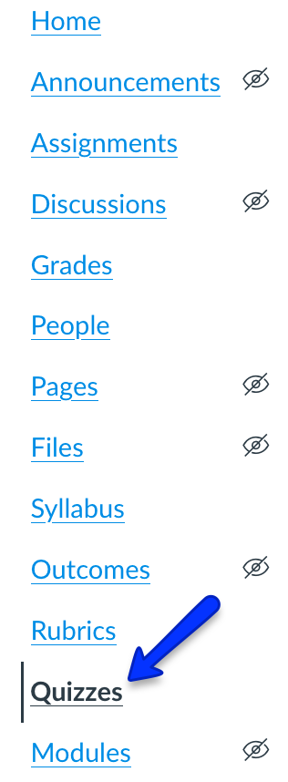
2. Set up your question bank | In the right corner, click the more options button and select Manage Question Banks | 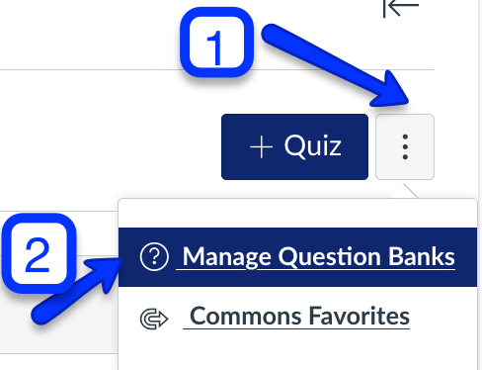
3. Add Question Bank | In the right corner, click Add Question Bank
4. Name your Question Bank | Type the name of the question bank in the text box and click enter/return.

